**MAWLANA BHASHANI SCIENCE AND TECHNOLOGY UNIVERSITY**

SANTOSH, TANGAIL-1902



DEPARTMENT OF INFORMATION AND COMMUNICATION TECHNOLOGY

**Course Title: Computer Programming Lab**

**Course Code: ICT-1104**

|  |  |
| --- | --- |
| Submitted By  **Name**: Kuldip Saha Mugdha  ID : IT-22018  1st Year 1st Semester  Session : 2021-2022  Dept of ICT, MBSTU | Submitted To  **Bikash Kumar Paul**  Assistant Professor  DEPARTMENT OF INFORMATION AND COMMUNICATION TECHNOLOGY  **MAWLANA BHASHANI SCIENCE AND TECHNOLOGY UNIVERSITY** |

**INDEX**

|  |  |  |
| --- | --- | --- |
| **SL** | **Name** | **Page**  **No** |
| 1 | 1.1.Determine the number is square number or not | 1 |
|  | 1.2. Celsius to Fahrenheit | 1 |
|  | 1.3.Determining the distance between two coordinates | 2 |
| 2 | 2.1.Write a C program to determine the year is leap year or not leap year | 5 |
|  | 2.2Write a C program to determine a student is passed or failed in his/her math exam | 5 |
|  | 2.3.Write a C program to determine the number is even or odd | 6 |
| 3 | 3.1.Write a C program to print the inputted number and terminate the program when the value is zero | 9 |
|  | 3.2.Write a C program to print 1 to 5 using goto statement | 10 |
|  | 3.3.Write a C program to show all the digits from 0-9 excluding 5 | 10 |
|  | 3.4. Write a C program to show the name of tense from the digit 1-3 using switch case | 11 |
| 4 | 4.1.Write a C program to print 1 to 5 all numbers | 14 |
|  | 4.2.Write a C program to print 1 to 10 all odd numbers | 14 |
|  | 4.3.Write a C program to print 1 to 10 all even numbers | 15 |

|  |  |  |
| --- | --- | --- |
| **SL** | **Name** | **Page No** |
| 5 | 5.1.Write a Program that can print any random number | 18 |
| 6 | 6.1.Write a program that can sort any five numbers in ascending order | 20 |
| 7 | 7.1. Write a c program that can search a number from a array | 23 |
| 8 | 8.1. Finding the number of unique values among 10 numbers using array | 34 |
|  | 8.2. Summation of Two Matrixes | 35 |
|  | 8.3. Finding maximum and minimum numbers among 10 | 38 |
| 9 | 9.1. Sum of natural numbers using recursive function | 41 |
|  | 9.2. Calculates the factorial of a number using a recursive function | 41 |
|  | 9.3. Generates the Fibonacci series for a given number using a recursive function | 42 |
| **SL** | **Name** | **Page No** |
| 10 | 10.1. Write a program in c that print the number of word in a string | 45 |
|  | 10.2. Write a program in c that print reverse  order in a string | 46 |
|  | 10.3. Write a program in c that print ascending  and descending order in a string | 47 |
| 11 |  |  |
|  |  |  |
|  |  |  |
| 12 | 12.1. Write a program in C to add two numbers using pointers | 33 |
|  | 12.2. Write a program in C to count the number of vowels and consonants in a string using a pointer | 34 |
|  | 12.3. Write a program in C to show how a function returning pointer | 35 |
| 13 | 13.1. Write a program that read two numbers and display Bitwise AND | 37 |
|  | 13.2. Write a program that read two numbers and display Bitwise OR | 37 |
|  | 13.3 Write a program that read two numbers and display Bitwise Exclusive OR | 38 |
| 14 | 14.1. A file named DATA contains a series of integer numbers. Code a program to read these numbers and then all ‘ODD’ numbers to a file be called ODD and all ‘EVEN’ numbers to file to be called EVEN. | 40 |
|  | 14.2. Receives strings from keyboard and writes them to file | 41 |
|  |  |  |

**MAWLANA BHASHANI SCIENCE AND TECHNOLOGY UNIVERSITY**

SANTOSH, TANGAIL-1902



DEPARTMENT OF INFORMATION AND COMMUNICATION TECHNOLOGY

**Course Title: Computer Programming Lab**

**Course Code: ICT-1104**

|  |  |
| --- | --- |
| **Date of Performance:** 15 July,2023  **Date of Submission:** 17 July,2023 |  |

**Lab Report No: 01**

|  |  |
| --- | --- |
| Submitted By | Submitted To |
| Name: Kuldip Saha Mugdha  ID : IT-22018  1st Year 1st Semester  Session : 2021-2022  Dept of ICT, MBSTU | **Bikash Kumar Paul**  Assistant Professor  DEPARTMENT OF INFORMATION AND COMMUNICATION TECHNOLOGY  **MAWLANA BHASHANI SCIENCE AND TECHNOLOGY UNIVERSITY** |

1.1: **Write a C program to determine the number is square number or not:**

**Source Code:**

#include<stdio.h>

#include<math.h>

int main()

{

int n,k,x;

scanf("%d",&n);

x=sqrt(n);

k=x*x;

if(n==k)

printf("%d is a square number",n);

else

printf("%d is not a square number",n);

return 0;

}

**Sample Input:**

18

**Sample Output:**

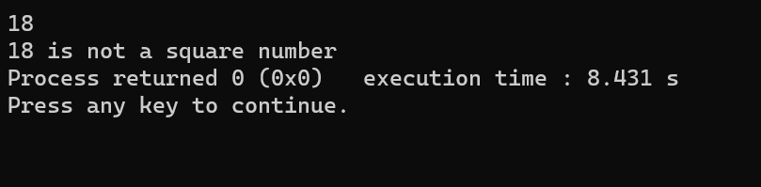

**1.2: Write a C program that convert a temperature from Celsius to Fahrenheit:**

**Source Code:**

#include<stdio.h>

#include<math.h>

int main()

{

float c,f;

printf("Enter the value of C : ");

scanf("%f",&c);

f=(9*c/5)+32;

printf("%lf",f);

return 0;

}

**Sample input:**

18

**Sample output:**

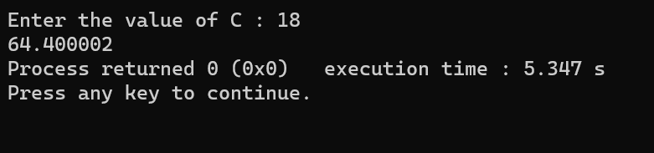

**1.3. Write a C program to determine the distance between two coordinates:**

**Source Code:**

#include<stdio.h>

#include<math.h>

int main()

{

int x1,y1,x2,y2;

float d;

scanf("%d%d%d%d",&x1,&y1,&x2,&y2);

d=sqrt(pow((x1-x2),2)+pow((y1-y2),2));

printf("%.4f",d);

return 0;

}

**Simple input:**

1 1 2 2

**Simple output:**

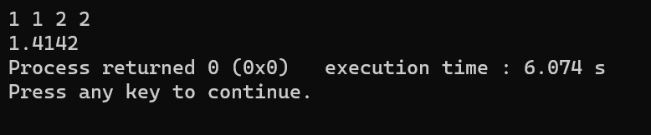

**MAWLANA BHASHANI SCIENCE AND TECHNOLOGY UNIVERSITY**

SANTOSH, TANGAIL-1902



DEPARTMENT OF INFORMATION AND COMMUNICATION TECHNOLOGY

**Course Title: Computer Programming Lab**

**Course Code: ICT-1104**

|  |  |
| --- | --- |
| **Date of Performance:** 15 July,2023  **Date of Submission:** 17 July,2023 |  |

**Lab Report No: 02**

|  |  |
| --- | --- |
| Submitted By | Submitted To |
| Name: Kuldip Saha Mugdha  ID : IT-22018  1st Year 1st Semester  Session : 2021-2022  Dept of ICT, MBSTU | **Bikash Kumar Paul**  Assistant Professor  DEPARTMENT OF INFORMATION AND COMMUNICATION TECHNOLOGY  **MAWLANA BHASHANI SCIENCE AND TECHNOLOGY UNIVERSITY** |

**2.1. Write a C program to determine the year is leap year or not leap year.**

**Source Code:**

#include<stdio.h>

int main()

{

int year;

printf("Enter any year:");

scanf("%d",&year);

if(year%400==0 || year%4==0 && year%100!=0)

{

printf("%d is Leap Year",year);

}

else

{

printf("%d is not Leap Year",year);

}

return 0;

}

**Sample Input:**

2004

**Sample Output:**

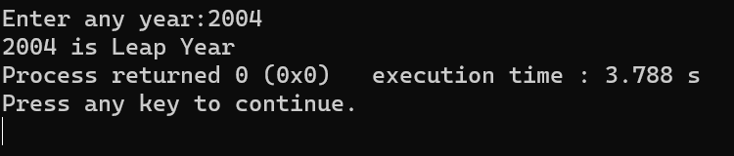

**2.2. Write a C program to determine a student is passed or failed in his/her math exam.**

**Source Code:**

#include<stdio.h>

int main()

{

int n;

printf("Enter the marks : ");

scanf("%d",&n);

if(n<33)

printf("Failed\n");

else

printf("Passed\n");

return 0;

}

**Sample Input:**

82

**Sample Output:**

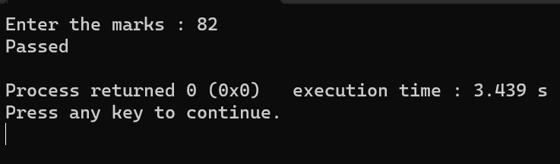

**2.3. Write a C program to determine the number is even or odd.**

**Source Code:**

     #include<stdio.h>

int main()

{

int x;

printf("Insert any number: ");

scanf("%d",&x);

if(x%2==0)

printf("even\n",x);

else

printf("odd\n",x);

return 0;

}

**Sample Input:**

18

**Sample Output:**

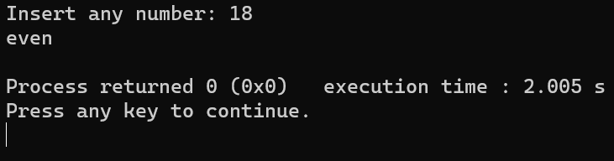

**MAWLANA BHASHANI SCIENCE AND TECHNOLOGY UNIVERSITY**

SANTOSH, TANGAIL-1902



DEPARTMENT OF INFORMATION AND COMMUNICATION TECHNOLOGY

**Course Title: Computer Programming Lab**

**Course Code: ICT-1104**

|  |  |
| --- | --- |
| **Date of Performance:** 15 July,2023  **Date of Submission:** 17 July,2023 |  |

**Lab Report No: 03**

|  |  |
| --- | --- |
| Submitted By | Submitted To |
| Name: Kuldip Saha Mugdha  ID : IT-22018  1st Year 1st Semester  Session : 2021-2022  Dept of ICT, MBSTU | **Bikash Kumar Paul**  Assistant Professor  DEPARTMENT OF INFORMATION AND COMMUNICATION TECHNOLOGY  **MAWLANA BHASHANI SCIENCE AND TECHNOLOGY UNIVERSITY** |

**3.1 : Write a C program to print the inputted number and terminate the program when the value is zero.**

**Source Code:**

#include<stdio.h>

int main()

{

int n;

while(scanf("%d",&n)==1)

{

if(n==0)

break;

else

printf("%d\n",n);

}

return 0;

}

**Sample Input :**

2

1

0

**Sample Output :**

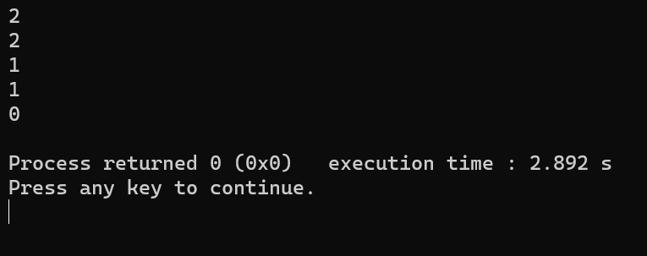

**3.2 : Write a C program to print 1 to 5 using goto statement.**

**Source Code:**

#include<stdio.h>

int main()

{

int i=1;

start:

printf("%d\n",i);

i++;

if(i<=5)

goto start;

return 0;

}

**Sample input :**

**Sample Output :**

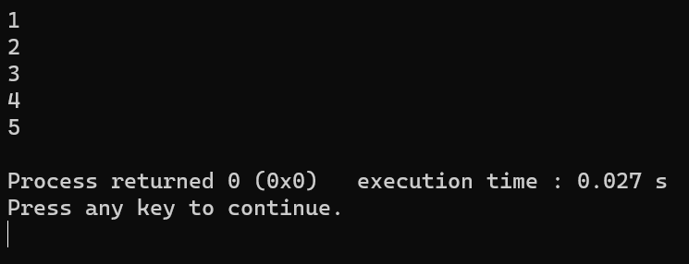

**3.3 : Write a C program to show all the digits from 0-9 excluding 5.**

**Source Code:**

#include<stdio.h>

int main()

{

int i;

for(i=0;i<10;i++)

{

if(i==5)

continue;

printf("%d\n",i);

}

return 0;

}

**Sample Input:**

**Sample Output :**

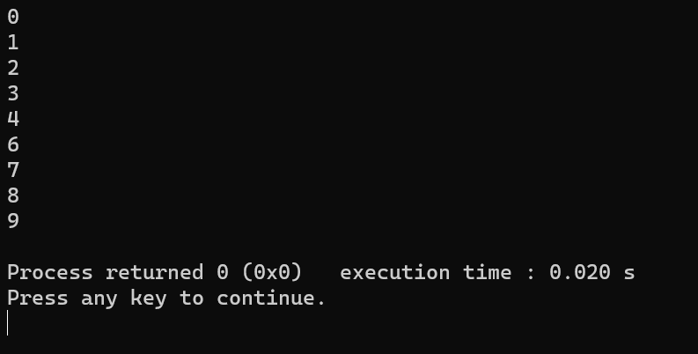

**3.4. Write a C program to show the name of tense from the digit 1-3 using switch case.**

**Source Code:**

#include<stdio.h>

int main()

{

int n;

scanf("%d",&n);

switch(n)

{

case 1:

printf("Present Tense\n");

break;

case 2:

printf("Past Tense\n");

break;

case 3:

printf("Future Tense\n");

break;

default:

printf("Enter the value again\n");

break;

}

return 0;

}

**Sample Input:**

1

**Sample Output :**

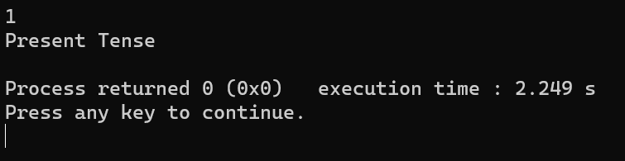

**MAWLANA BHASHANI SCIENCE AND TECHNOLOGY UNIVERSITY**

SANTOSH, TANGAIL-1902



DEPARTMENT OF INFORMATION AND COMMUNICATION TECHNOLOGY

**Course Title: Computer Programming Lab**

**Course Code: ICT-1104**

**Date of Performance:** 15 July,2023

**Date of Submission:** 17 July,2023

**Lab Report No: 04**

|  |  |
| --- | --- |
| Submitted By | Submitted To |
| Name: Kuldip Saha Mugdha  ID : IT-22018  1st Year 1st Semester  Session : 2021-2022  Dept of ICT, MBSTU | **Bikash Kumar Paul**  Assistant Professor  DEPARTMENT OF INFORMATION AND COMMUNICATION TECHNOLOGY  **MAWLANA BHASHANI SCIENCE AND TECHNOLOGY UNIVERSITY** |

**4.1: Write a C program to print 1 to 5 all numbers .**

**Source Code:**

#include<stdio.h>

int main()

{

int i;

for(i=1;i<=5;i++)

{

printf("%d\n",i);

}

return 0;

}

**Sample Input:**

**Sample Output:**

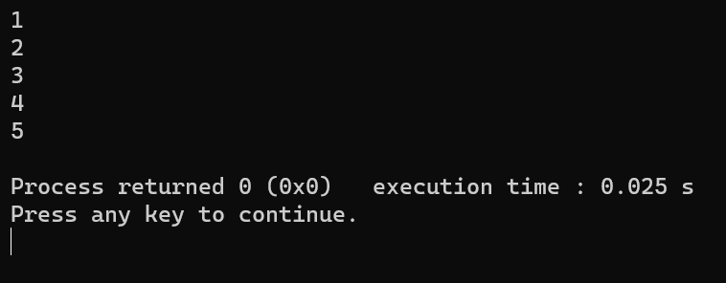

**4.2: Write a C program to print 1 to 10 all odd numbers.**

**Source Code:**

#include<stdio.h>

int main()

{

int i=1;

while(i<=10)

{

if(i%2!=0)

printf("%d\n",i);

i++;

}

return 0;

}

**Sample Input:**

**Sample Output:**

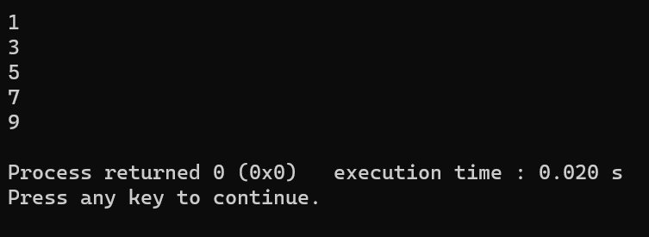

**4.3: Write a C program to print 1 to 10 all even numbers .**

**Source Code:**

#include<stdio.h>

int main()

{

int i=1;

do

{

if(i%2==0)

printf("%d\n",i);

i++;

}while(i<=10);

return 0;

}

**Sample Input:**

**Sample Output:**

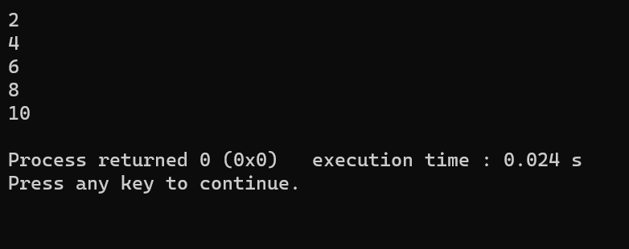

**MAWLANA BHASHANI SCIENCE AND TECHNOLOGY UNIVERSITY**

SANTOSH, TANGAIL-1902



DEPARTMENT OF INFORMATION AND COMMUNICATION TECHNOLOGY

**Course Title: Computer Programming Lab**

**Course Code: ICT-1104**

|  |  |
| --- | --- |
| **Date of Performance:** 15 July,2023  **Date of Submission:** 17 July,2023 |  |

**Lab Report No: 05**

|  |  |
| --- | --- |
| Submitted By | Submitted To |
| Name: Kuldip Saha Mugdha  ID : IT-22018  1st Year 1st Semester  Session : 2021-2022  Dept of ICT, MBSTU | **Bikash Kumar Paul**  Assistant Professor  DEPARTMENT OF INFORMATION AND COMMUNICATION TECHNOLOGY  **MAWLANA BHASHANI SCIENCE AND TECHNOLOGY UNIVERSITY** |

**5.1 : Write a program that that can print any random number .**

**Source Code:**

#include<stdio.h>

#include<stdlib.h>

int main()

{

int a[1000],i;

for(i=1;i<=5;i++)

a[i]=rand()%30+50;

for(i=1;i<=5;i++)

printf("index[%d]=%d\n",i,a[i]);

return 0;

}

**Sample Input:**

**Sample Output:**

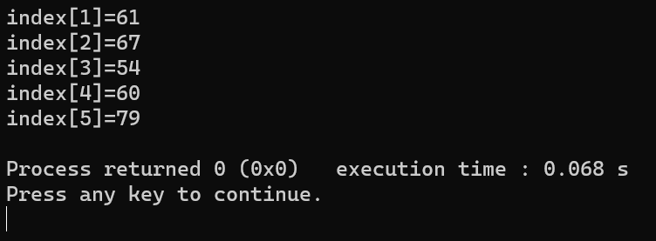

**MAWLANA BHASHANI SCIENCE AND TECHNOLOGY UNIVERSITY**

SANTOSH, TANGAIL-1902



DEPARTMENT OF INFORMATION AND COMMUNICATION TECHNOLOGY

**Course Title: Computer Programming Lab**

**Course Code: ICT-1104**

|  |  |
| --- | --- |
| **Date of Performance:** 15 July,2023  **Date of Submission:** 17 July,2023 |  |

**Lab Report No: 06**

|  |  |
| --- | --- |
| Submitted By | Submitted To |
| Name: Kuldip Saha Mugdha  ID : IT-22018  1st Year 1st Semester  Session : 2021-2022  Dept of ICT, MBSTU | **Bikash Kumar Paul**  Assistant Professor  DEPARTMENT OF INFORMATION AND COMMUNICATION TECHNOLOGY  **MAWLANA BHASHANI SCIENCE AND TECHNOLOGY UNIVERSITY** |

**6.1. Write a program that can sort any five numbers in ascending order.**

**Source Code:**

#include<stdio.h>

int main()

{

int i,j,a[100],temp,f;

for(i=0;i<5;i++)

{

scanf("%d",&a[i]);

}

for(i=0;i<4;i++)

{

f=0;

for(j=0;j<4-i;j++)

{

if(a[j]>a[j+1])

{

temp=a[j];

a[j]=a[j+1];

a[j+1]=temp;

f=1;

}

}

if(f==0)

{

break;

}

}

for(i=0;i<5;i++)

printf("%d ",a[i]);

}

**Sample Input :**

4 5 1 3 2

**Sample Output:**

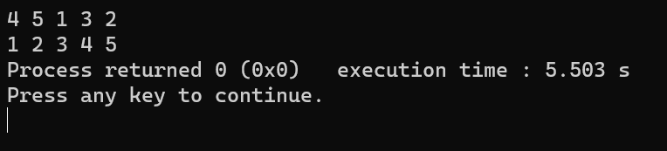

**MAWLANA BHASHANI SCIENCE AND TECHNOLOGY UNIVERSITY**

SANTOSH, TANGAIL-1902



DEPARTMENT OF INFORMATION AND COMMUNICATION TECHNOLOGY

**Course Title: Computer Programming Lab**

**Course Code: ICT-1104**

|  |  |
| --- | --- |
| **Date of Performance:** 15 July,2023  **Date of Submission:** 17 July,2023 |  |

**Lab Report No: 07**

|  |  |
| --- | --- |
| Submitted By | Submitted To |
| Name: Kuldip Saha Mugdha  ID : IT-22018  1st Year 1st Semester  Session : 2021-2022  Dept of ICT, MBSTU | **Bikash Kumar Paul**  Assistant Professor  DEPARTMENT OF INFORMATION AND COMMUNICATION TECHNOLOGY  **MAWLANA BHASHANI SCIENCE AND TECHNOLOGY UNIVERSITY** |

**7.1 : Write a c program that can search a number from a array.**

**Source Code:**

#include<stdio.h>

int main()

{

int s,a[100],i,count=0;

for(i=1;i<=100;i++)

{

a[i]=rand()%500+100;

printf("%d\n",a[i]);

}

scanf("%d",&s);

for(i=0;i<100;i++)

{

if(a[i]==s)

{

printf("Data is found\n");

count++;

break;

}

}

if(count==0)

{

printf("Not Found\n");

}

return 0;

}

**Sample Input :**

18

**Sample Output:**

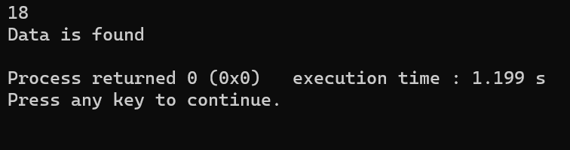

**MAWLANA BHASHANI SCIENCE AND TECHNOLOGY UNIVERSITY**

SANTOSH, TANGAIL-1902



DEPARTMENT OF INFORMATION AND COMMUNICATION TECHNOLOGY

**Course Title: Computer Programming Lab**

**Course Code: ICT-1104**

|  |  |
| --- | --- |
| **Date of Performance:** 15 July,2023  **Date of Submission:** 17 July,2023 |  |

**Lab Report No: 08**

|  |  |
| --- | --- |
| Submitted By | Submitted To |
| Name: Kuldip Saha Mugdha  ID : IT-22018  1st Year 1st Semester  Session : 2021-2022  Dept of ICT, MBSTU | **Bikash Kumar Paul**  Assistant Professor  DEPARTMENT OF INFORMATION AND COMMUNICATION TECHNOLOGY  **MAWLANA BHASHANI SCIENCE AND TECHNOLOGY UNIVERSITY** |

**8.1 : Finding the number of unique values among 10 numbers using array .**

**Source Code:**

#include<stdio.h>

int main()

{

    int i,j,k[10],d[10],n,x,y;

    for(i=0; i<10; i++)

        scanf("%d", &k[i]);

    for(i=0; i<10; i++)

        d[i]=k[i];

    for(i=0; i<10; i++)

    {

        n=1;

        for(j=i+1; j<10; j++)

        {

            if(k[i]==k[j])

            {

                n++;

                d[j]=0;

            }

        }

        if(d[i]!=0)

            printf("%d-%d\n", d[i], n);

    }

   return 0;

}

------------------------------------------

Sample Input:

2 2 5 7 8 7 1 2 8 3

Sample Output:

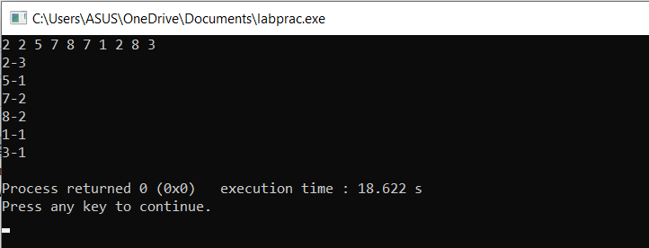

**8.2: Summation of Two Matrices.**

**Source Code:**

#include<stdio.h>

int main()

{

    int i,a[10][10], b[10][10], sum[10][10], j, r, c;

    printf("Row and column of both matrix must be same.\n");

    printf("Enter Mat A order:\n");

    scanf("%d %d", &r, &c);

    printf("Enter elements:\n");

    for(i=1; i<=r; i++)

        for(j=1; j<=c; j++)

            scanf("%d", &a[i][j]);

    printf("Matrix A:\n");

    for(i=1; i<=r; i++)

    {

        for(j=1; j<=c; j++)

            printf("%d ", a[i][j]);

        printf("\n");

    }

    printf("Enter Matrix B order:\n");

    scanf("%d %d", &r, &c);

    printf("Enter elements:\n");

    for(i=1; i<=r; i++)

        for(j=1; j<=c; j++)

            scanf("%d", &b[i][j]);

    printf("Matrix B:\n");

    for(i=1; i<=r; i++)

    {

        for(j=1; j<=c; j++)

            printf("%d ", b[i][j]);

        printf("\n");

    }

    printf("Summataton of Mat A and B:\n");

    for(i=1; i<=r; i++)

    {

        for(j=1; j<=c; j++)

        {

            sum[i][j]=a[i][j]+b[i][j];

            printf("%d ", sum[i][j]);

        }

        printf("\n");

    }

return 0;

}

**Sample Input:**

2 2

1 4

6 7

2 2

5 6

2 1

**Sample Output:**

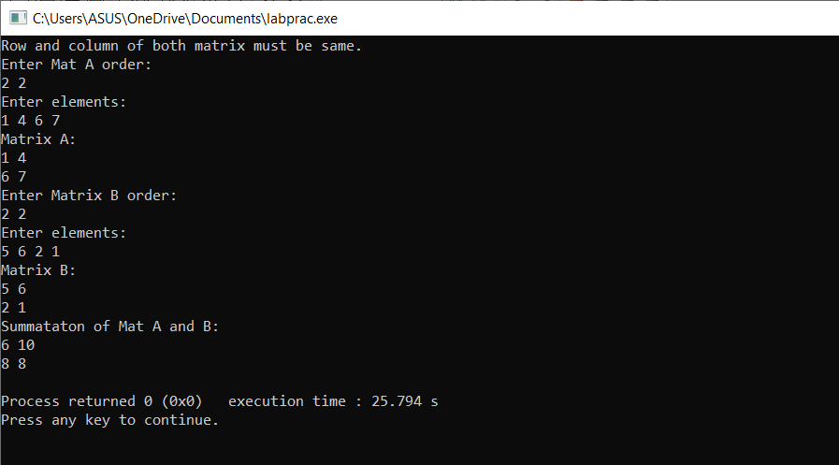

**8.3: Finding maximum and minimum numbers among 10 numbers using array.**

**Source Code:**

#include<stdio.h>

int main()

{

    int a[10],b[10] ,i;

   printf(“Enter 10 numbers:\n”);

    for(i=0; i<10; i++)

    {

        scanf("%d", &a[i]);

        b[i]=a[i];

    }

    for(i=0; i<10; i++)

    {

        if(a[0]<a[i])

            a[0]=a[i];

    }

    printf("Maximum = %d\n", a[0]);

    for(i=0; i<10; i++)

    {

        if(b[0]>a[i])

            b[0]= b[i];

    }

    printf("Minimum = %d", b[0]);

    return 0;

}

**Sample Input:**

Enter 10 numbers:

1 2 3 4 5 6 7 8 9 10

**Sample Output:**

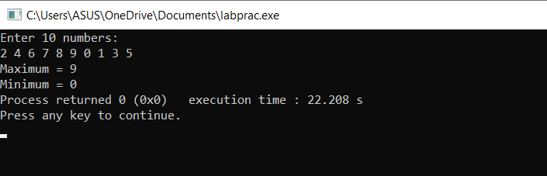

**MAWLANA BHASHANI SCIENCE AND TECHNOLOGY UNIVERSITY**

SANTOSH, TANGAIL-1902



DEPARTMENT OF INFORMATION AND COMMUNICATION TECHNOLOGY

**Course Title: Computer Programming Lab**

**Course Code: ICT-1104**

|  |  |
| --- | --- |
| **Date of Performance:** 12 June,2022  **Date of Submission:** 19 June,2022 |  |

**Lab Report No: 09**

|  |  |
| --- | --- |
| Submitted By | Submitted To |
| Name: Kuldip Saha Mugdha  ID : IT-22018  1st Year 1st Semester  Session : 2021-2022  Dept of ICT, MBSTU | **Bikash Kumar Paul**  Assistant Professor  DEPARTMENT OF INFORMATION AND COMMUNICATION TECHNOLOGY  **MAWLANA BHASHANI SCIENCE AND TECHNOLOGY UNIVERSITY** |

**9.1: Sum of natural numbers using recursive function.**

**Source Code:**

#include <stdio.h>

int sum(int n);

int main()

 {

    int number, result;

    printf("Enter a positive integer: ");

    scanf("%d", &number);

    result = sum(number);

    printf("sum = %d", result);

    return 0;

}

int sum(int n) {

    if (n != 0)

        // sum() function calls itself

        return n + sum(n-1);

    else

        return n;}

**Sample Input:**

10

**Sample Output:**

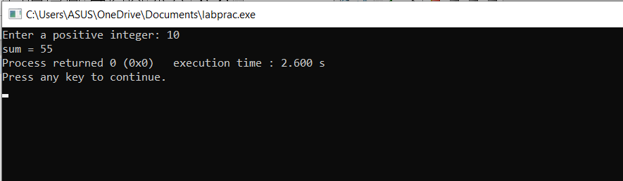

**9.2: Calculates the factorial of a  number using a recursive function.**

**Source Code:**

#include <stdio.h>

unsigned long long int factorial(unsigned int i) {

if(i <= 1) {

      return 1;

   }

   return i * factorial(i - 1);

}

int  main() {

   int i ;

   printf("Please Enter a Positive Integer:\n");

   scanf("%d",&i);

   printf("Factorial of %d is %d\n", i, factorial(i));

   return 0;

}

**Sample Input:**

4

**Sample Output:**

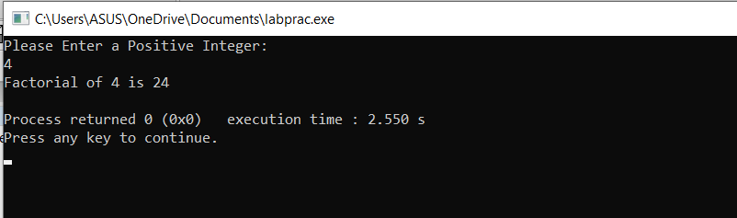

**9.3: Generates the Fibonacci series for a given number using a recursive function.**

**Source Code:**

Source Code:

#include <stdio.h>

int fibonacci(int i) {

   if(i == 0) {

      return 0;

   }

   if(i == 1) {

      return 1;

   }

   return fibonacci(i-1) + fibonacci(i-2);

}

int  main() {

   int i;

   for (i = 0; i < 10; i++) {

      printf("%d\t", fibonacci(i));

   }

   return 0;

}

**Sample Input:**

**Sample Output:**

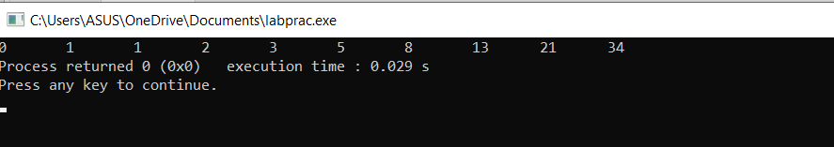

**MAWLANA BHASHANI SCIENCE AND TECHNOLOGY UNIVERSITY**

SANTOSH, TANGAIL-1902



DEPARTMENT OF INFORMATION AND COMMUNICATION TECHNOLOGY

**Course Title: Computer Programming Lab**

**Course Code: ICT-1104**

|  |  |
| --- | --- |
| **Date of Performance:** 19 June,2022  **Date of Submission:** 26 June,2022 |  |

**Lab Report No: 10**

|  |  |
| --- | --- |
| Submitted By | Submitted To |
| Name: Kuldip Saha Mugdha  ID : IT-22018  1st Year 1st Semester  Session : 2021-2022  Dept of ICT, MBSTU | **Bikash Kumar Paul**  Assistant Professor  DEPARTMENT OF INFORMATION AND COMMUNICATION TECHNOLOGY  **MAWLANA BHASHANI SCIENCE AND TECHNOLOGY UNIVERSITY** |

**10.1.  Write a program in c that print the number of word in a string.**

**Source Code:**

#include<stdio.h>

int main()

{

    char word[100];

    int i,count;

    while((gets(word))!=EOF)

    {

            i=0;

            count=1;

            while(word[i]!='\0')

            {

                  if(word[i]==' ' || word[i]=='\n' || word[i]=='\t')

                  {

                        count++;

                  }

                  i++;

            }

            printf("total word: %d\n",count);

    }

    return 0;

}

**Sample input:**

What is your name.

I love sleeping.

bangladesh.

**Sample output:**

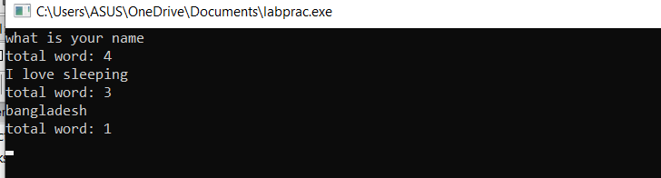

**10.2.  Write a program in c that print reverse order in a string.**

**Source Code:**

#include<stdio.h>

#include<string.h>

int main()

{

    char name[100];

    int l,i;

      while(gets(name)!=EOF)

      {

            l=strlen(name);

            printf("Rever order:");

            for(i=l;i>=0;i--)

            {

                  printf("%c",name[i]);

            }

            printf("\n");

      }

     return 0;

}

**Sample input:**

Siyam

atikur

nayan

**Sample output:**

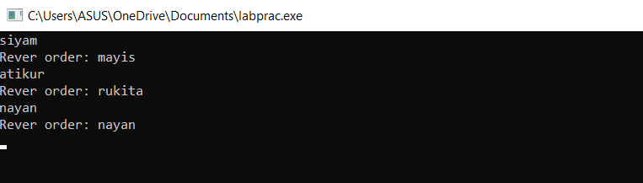

**10.3.  Write a program in c that print ascending and descending order in a string.**

**Source Code:**

#include<stdio.h>

int main()

{

      char ascen[1000];

      int l,i,j,swap;

      while((gets(ascen))!=EOF)

      {

            l=strlen(ascen);

            for(i=1;i<l;i++)

            {

                  for(j=0;j<l-i;j++)

                   {

                        if(ascen[j]>ascen[j+1])

                        {

                              swap=ascen[j+1];

                              ascen[j+1]=ascen[j];

                              ascen[j]=swap;

                        }

                   }

            }

            printf("Ascending Order:");

            for(i=0;i<l;i++)

            {

                  printf("%c",ascen[i]);

            }

            printf("\n");

            for(i=1;i<l;i++)

            {

                  for(j=0;j<l-i;j++)

                   {

                        if(ascen[j]<ascen[j+1])

                        {

                              swap=ascen[j+1];

                              ascen[j+1]=ascen[j];

                              ascen[j]=swap;

                        }

                   }

            }

            printf("Descending Order:");

            for(i=0;i<l;i++)

            {

                  printf("%c",ascen[i]);

            }

            printf("\n");

      }

}

**Sample input:**

Bad

siyam

**Sample Output:**

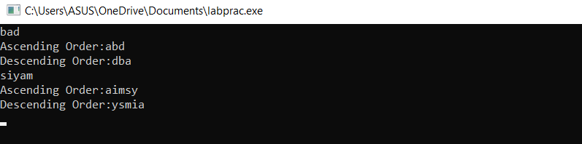

**MAWLANA BHASHANI SCIENCE AND TECHNOLOGY UNIVERSITY**

SANTOSH, TANGAIL-1902



DEPARTMENT OF INFORMATION AND COMMUNICATION TECHNOLOGY

**Course Title: Computer Programming Lab**

**Course Code: ICT-1104**

|  |  |
| --- | --- |
| **Date of Performance:**  **Date of Submission:** |  |

**Lab Report No: 12**

|  |  |
| --- | --- |
| Submitted By | Submitted To |
| Name: Kuldip Saha Mugdha  ID : IT-22018  1st Year 1st Semester  Session : 2021-2022  Dept of ICT, MBSTU | **Bikash Kumar Paul**  Assistant Professor  DEPARTMENT OF INFORMATION AND COMMUNICATION TECHNOLOGY  **MAWLANA BHASHANI SCIENCE AND TECHNOLOGY UNIVERSITY** |

**12.1: Write a program in C to add two numbers using pointers.**

**Source Code:**

#include <stdio.h>

int main()

{

int fno, sno, *ptr, *qtr, sum,t;

for(int i=1;i<=3;i++){

printf(" Input the first number : ");

scanf("%d", &fno);

printf(" Input the second number : ");

scanf("%d", &sno);

ptr = &fno;

qtr = &sno;

sum = *ptr + *qtr;

printf(" Case %d: The sum of the entered numbers is - %d\n\n",i,sum);

}

return 0;

}

1

**Sample Input:**

7 9

5 0

**Sample Output:**

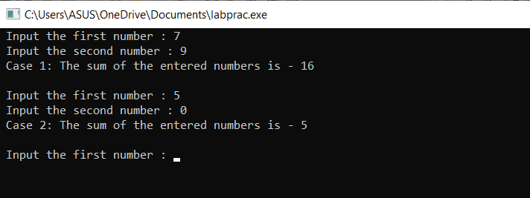

**12.2: Write a program in C to count the number of vowels and**

**consonants in a string using a pointer.**

**Source Code:**

#include <stdio.h>

int main()

{

char str1[50];

char *pt;

int ctrV,ctrC;

for(int i=1;i<=3;i++){

printf(" Input a string: ");

fgets(str1, sizeof str1, stdin);

pt=str1;

ctrV=ctrC=0;

while(*pt!='\0')

{

if(*pt=='A' ||*pt=='E' ||*pt=='I' ||*pt=='O' ||*pt=='U' ||*pt=='a' ||*pt=='e' ||*pt=='i' ||*pt=='o'

||*pt=='u')

1

ctrV++;

else

ctrC++; pt++;

}

printf(" Number of vowels : %d\n Number of consonants : %d\n",ctrV,ctrC-1);

}

return 0;

}

**Sample Input:**

shafi

siyam

**Sample Output:**

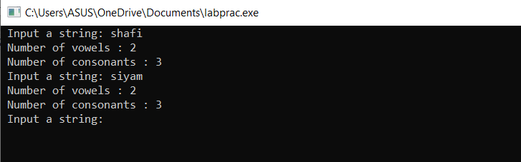

**12.3: Write a program in C to show how a function**

**returning pointer.**

**Source Code:**

#include <stdio.h>

int* findLarger(int*, int*);

void main()

{

int numa=0;

int numb=0;

int *result;

for(int i=1;i<=3;i++){

printf(" Input the first number : ");

scanf("%d", &numa);

printf(" Input the second number : ");

scanf("%d", &numb);

result=findLarger(&numa, &numb);

printf(" The number %d is larger. \n\n",*result);

}

}

int* findLarger(int *n1, int *n2)

{

if(*n1 > *n2)

return n1;

else

return n2;

}

**Sample Input:**

15 46

4 6

**Sample Output:**

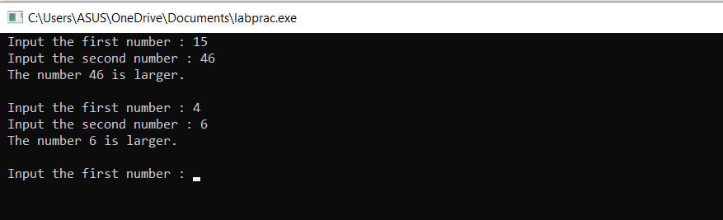

**MAWLANA BHASHANI SCIENCE AND TECHNOLOGY UNIVERSITY**

SANTOSH, TANGAIL-1902



DEPARTMENT OF INFORMATION AND COMMUNICATION TECHNOLOGY

**Course Title: Computer Programming Lab**

**Course Code: ICT-1104**

|  |  |
| --- | --- |
| **Date of Performance:**  **Date of Submission:** |  |

**Lab Report No: 13**

|  |  |
| --- | --- |
| Submitted By | Submitted To |
| Name: Kuldip Saha Mugdha  ID : IT-22018  1st Year 1st Semester  Session : 2021-2022  Dept of ICT, MBSTU | **Bikash Kumar Paul**  Assistant Professor  DEPARTMENT OF INFORMATION AND COMMUNICATION TECHNOLOGY  **MAWLANA BHASHANI SCIENCE AND TECHNOLOGY UNIVERSITY** |

**13.1: Write a program that read two numbers and display Bitwise AND.**

**Source Code:**

#include<stdio.h>

int main()

{

    int a,b,c;

    printf("Enter the value :");

    scanf("%d %d",&a,&b);

    c=a&b;

    printf("Result : %d",c);

    return 0;

}

**Sample input :**

7    5

**Sample Output :**

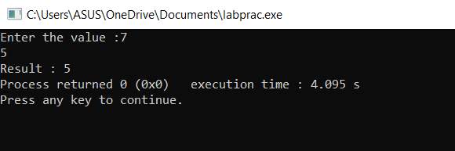

**13.2 : Write a program that read two numbers and display Bitwise OR.**

**Source Code:**

#include<stdio.h>

int main()

{

    int a,b,c;

    printf("Enter the value :");

    scanf("%d %d",&a,&b);

    c=a|b;

    printf("Result : %d",c);

    return 0;

}

**Sample Input :**

10     12

**Sample Output :**

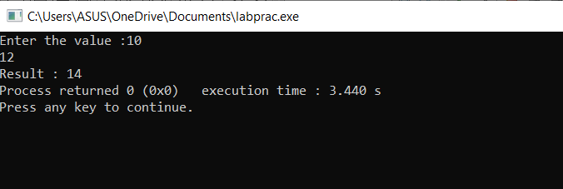

**13.3 : Write a program that read two numbers and display Bitwise Exclusive OR.**

**Source Code:**

#include<stdio.h>

int main()

{

    int a,b,c;

    printf("Enter the value :");

    scanf("%d %d",&a,&b);

    c=a^b;

    printf("Result : %d",c);

    return 0;

}

**Sample Input :**

9    15

**Sample Output :**

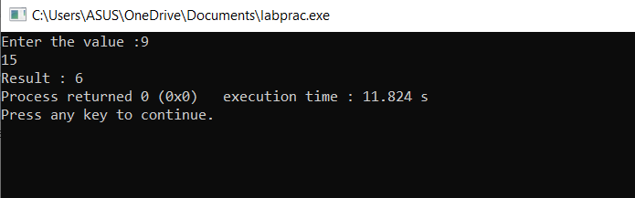

**MAWLANA BHASHANI SCIENCE AND TECHNOLOGY UNIVERSITY**

SANTOSH, TANGAIL-1902



DEPARTMENT OF INFORMATION AND COMMUNICATION TECHNOLOGY

**Course Title: Computer Programming Lab**

**Course Code: ICT-1104**

|  |  |
| --- | --- |
| **Date of Performance:**  **Date of Submission:** |  |

**Lab Report No: 14**

|  |  |
| --- | --- |
| Submitted By | Submitted To |
| Name: Kuldip Saha Mugdha  ID : IT-22018  1st Year 1st Semester  Session : 2021-2022  Dept of ICT, MBSTU | **Bikash Kumar Paul**  Assistant Professor  DEPARTMENT OF INFORMATION AND COMMUNICATION TECHNOLOGY  **MAWLANA BHASHANI SCIENCE AND TECHNOLOGY UNIVERSITY** |

**14.1.A file named DATA contains a series of integer numbers. Code a program to read these numbers and then all ‘ODD’ numbers to a file be called ODD and all ‘EVEN’ numbers to file to be called EVEN.**

**Source Code:**

#include<stdio.h>

int main()

{

    FILE *f1,*f2,*f3;

    int number,i;

    printf("Contents of DATA file\n\n");

    f1=fopen("DATA","w");

    for (i=1;i<=30;i++)

    {

        scanf("%d",&number);

        if(number==-1)

            break;

        putw(number,f1);

    }

    fclose(f1);

    f1=fopen("DATA","r");

    f2=fopen("ODD","w");

    f3=fopen("EVEN","w");

    while((number=getw(f1))!=EOF)

    {

        if(number%2==0)

            putw(number,f3);

        else

            putw(number,f2);

    }

    fclose(f1);

    fclose(f2);

    fclose(f3);

    f2=fopen("ODD","r");

    f3=fopen("EVEN","r");

    printf("\n\ncontents of ODD file\n\n");

    while((number=getw(f2))!=EOF)

  printf("%4d",number);

      printf("\n\ncontents of EVEN file\n\n");

       while((number=getw(f3))!=EOF)

        printf("%4d",number);

       fclose(f2);

       fclose(f3);

}

**Sample Input:**

7 8 6 5 4 0 76 43 12 -1

**Sample Output:**

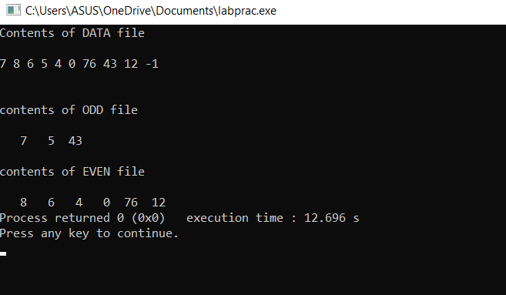

**14.2.Receives strings from keyboard and writes them to file**

**Source Code:**

#include <stdio.h>

#include<string.h>

int main()

{

    FILE *fp;

    char s[20];

    fp=fopen("output.txt","w");

    if(fp==NULL)

    {

        puts("Can not open file");

        exit(1);

    }

    printf("\nEnter a few lines of text\n");

    while(strlen(gets(s))<20)

    {

        fputs(s,fp);

        fputs("\n",fp);

    }

    fclose(fp);

    return 0;

}

**Sample Input:**

asalamu walikum

my name is siyam

dept of ict

1st year 1st semester

**Sample Output:**

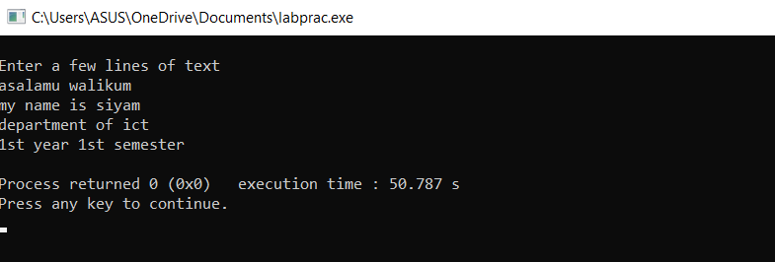

42